**What is Big O Notation?**

Big O Notation describes the upper bound of an algorithm’s running time. It helps us understand how an algorithm scales with input size n.

| **Notation** | **Meaning** | **Example** |
| --- | --- | --- |
| O(1) | Constant time | Accessing array[i] |
| O(n) | Linear time | Linear search |
| O(log n) | Logarithmic time | Binary search |
| O(n²) | Quadratic time | Bubble sort |

**Best, Average, and Worst Case**

| **Case** | **Linear Search** | **Binary Search (sorted array)** |
| --- | --- | --- |
| Best | O(1) (first item) | O(1) (middle item) |
| Average | O(n/2) → O(n) | O(log n) |
| Worst | O(n) | O(log n) |

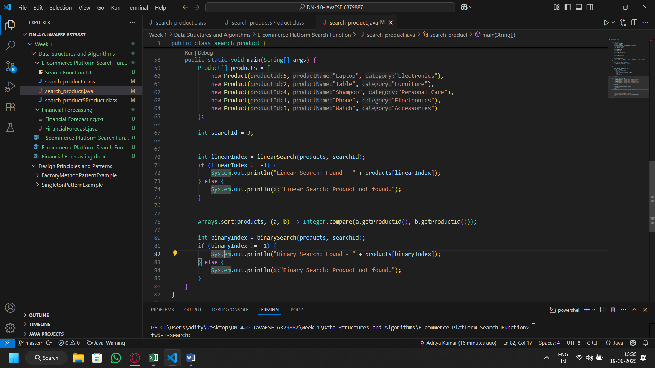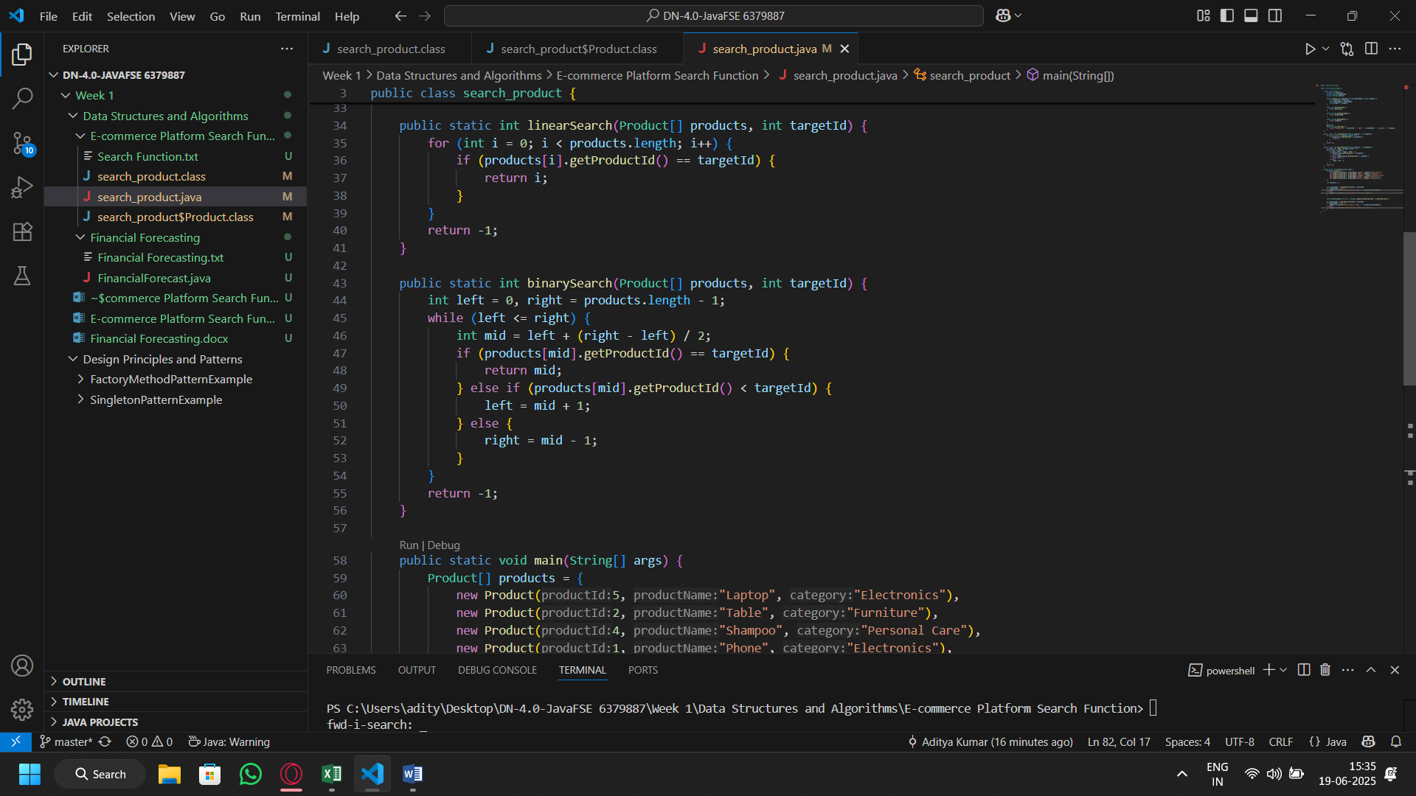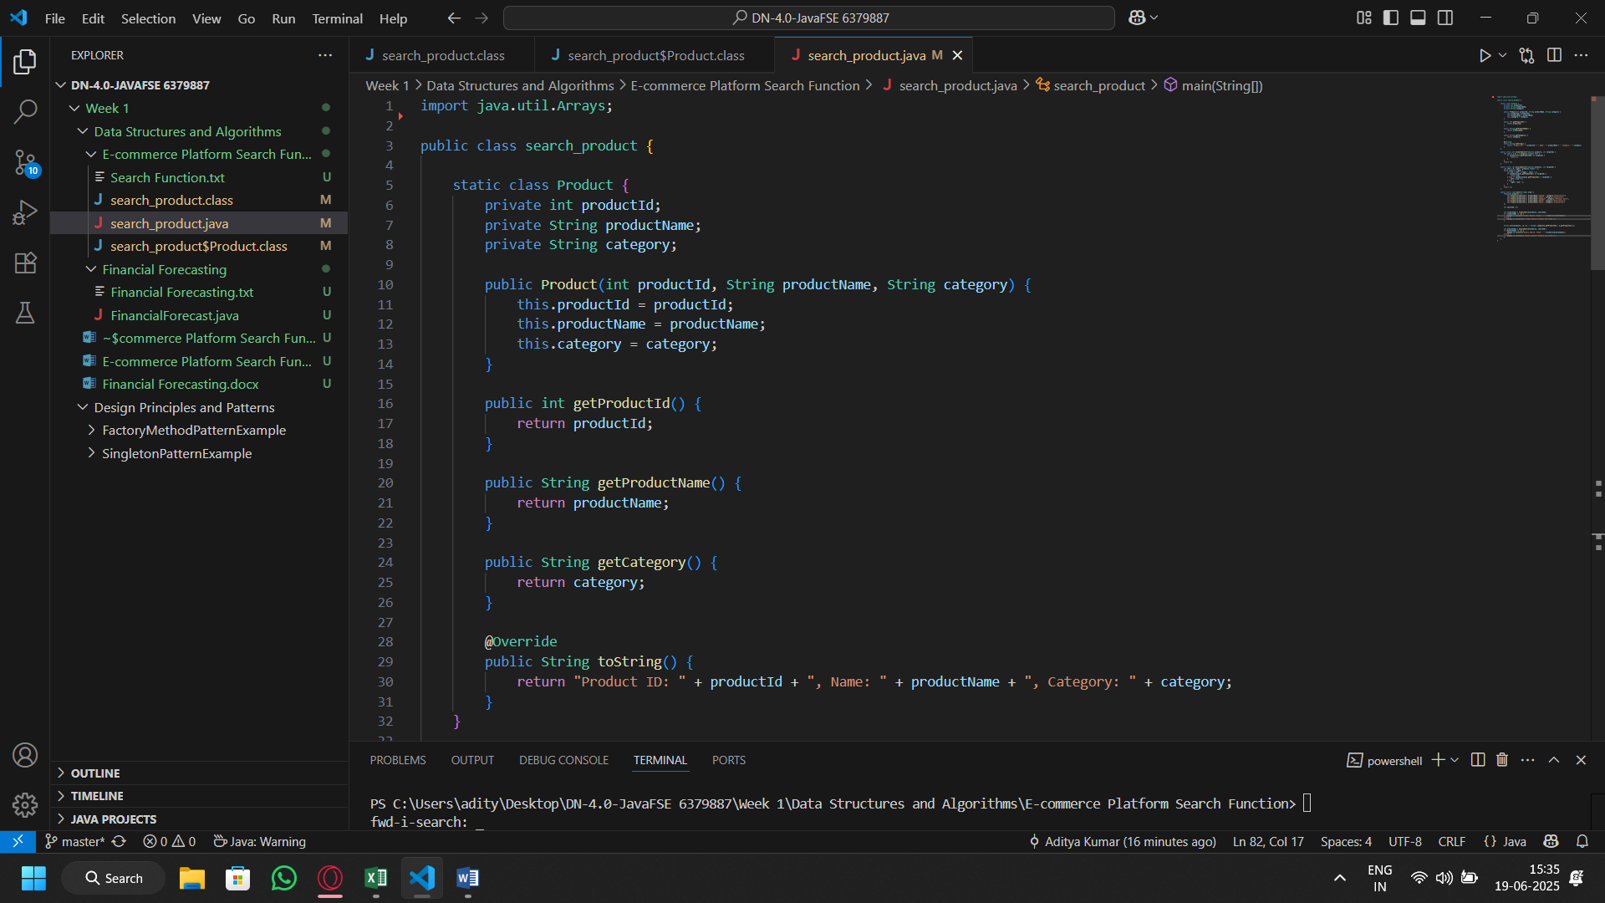Code:

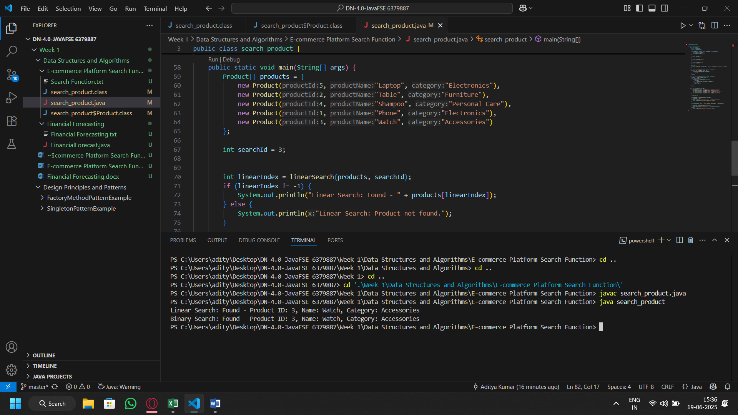Output: